Labor Market Report
November

aArkadnsas Dwepartmsent
of Workforce Services

www.discover.arkansas.gov

Table of Contents

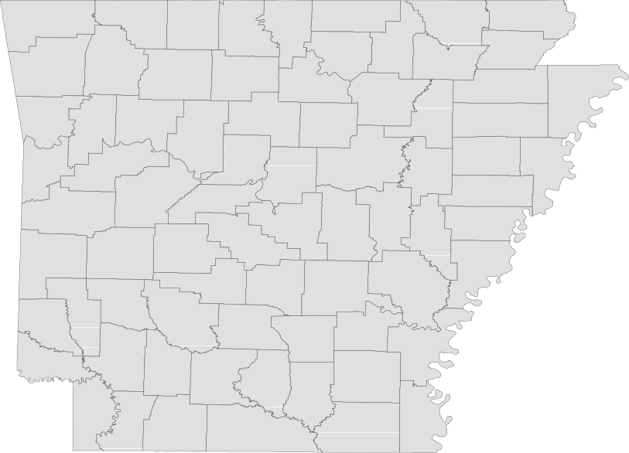

Technical Notes
Monthly Spotlight. 2
Arkansas Labor Force Summary. 3
Arkansas Nonfarm Payroll Jobs. 4
Arkansas Production Workers. 6
Metropolitan Statistical Areas. 7
Micropolitan Statistical Areas/Cities. 14
County Labor Force Statistics. 15
Local Workforce Development Areas. 18

The Arkansas Labor Market is prepared monthly in conjunction with the U.S. Depart- ment of Labor, Bureau of Labor Statistics (BLS). The current month’s estimates are preliminary, while previous month’s data is subject to revision.

Estimates of nonfarm payroll jobs show the number of jobs by industry and reflect employment by place of work. Hours and earnings estimates are based on payroll and worker-hour data collected for production workers in manufacturing industries.

Industries are classified according to the North American Industry Classification System (NAICS). All estimates are based on a first quarter 2018 benchmark.
Explanation of Terms and Concepts Monthly Business Survey of Employers
A monthly sample survey designed to provide industry information on nonfarm payroll jobs. Data are compiled each month from mail surveys and telephone interviews conducted by the Bureau of Labor Statistics in cooperation with Department of Work- force Services. The data are based on es- tablishment records and include all workers, full-or part-time, who received pay during the payroll period which includes the 12th of

the month. Approximately 5,000 Arkansas
business establishments are surveyed.
Metropolitan Statistical Area (MSA)

A term applied by the U.S. Office of Man- agement and Budget to counties that have one or more central cities and that meet specified criteria of population density, com- muting patterns and social and economic integration.
Current Population Survey (CPS)

A monthly sample survey of the popula- tion 16 years of age and over, designed to provide data on the labor force, the employed and the unemployed. The survey is conducted each month by the Bureau of the Census for BLS. The information is collected by trained interviewers from a sample of about 60,000 households. The data collected are based on the activity reported for the calendar week including the 12th of the month. Approximately 800 Arkansas households are represented in the sample survey.
Civilian Labor Force

The sum of all employed and unemployed persons 16 years of age or older. Members of the Armed Forces are excluded.

Employment

An estimate of the number of persons who worked any time for pay or profit or worked 15 hours or more as unpaid workers in a family business during the calendar week which includes the 12th of the month. Also included are those who, although not work- ing, had some job attachment and were not looking for work, and persons involved in labor management disputes.
Unemployment

An estimate of the number of persons who did not have a job, but were available for work and actively seeking work during the calendar week which includes the 12th of the month.
Unemployment Rate

The number of unemployed as a percentage of the civilian labor force. Unemployment rates are calculated from unrounded data.
Seasonal Adjustment

A statistical technique applied to monthly data to eliminate changes that normally oc- cur during the year due to seasonal events such as weather, major holidays, schedule shifts, harvest times, and the opening/clos- ing of schools.

www.discover.arkansas.gov

November Spotlight
Business Employment Dynamics (BED)
Business Employment Dynamics, also known as BED, tracks employment gains and losses at individual business locations. BED statistics are calculated from quarterly reports provided by employers to the Quarterly Census of Employment and Wages (QCEW) Program. Like QCEW data, BED statistics are produced and published on a quarterly basis. At this time, BED data is only available at the national and statewide levels.
The information produced from BED statistics includes gross job gains and losses at estab- lishments with changes in em- ployment. These employment changes occur when establish- ments open/expand or close/ contract. Gross job gains are a combination of jobs created from both openings of new businesses and expansions at existing businesses. Gross job losses are a combination of jobs lost from both exist- ing businesses that close and those that reduce their number of employees. The net change is the difference between gross job gains and gross job losses.
Gross Job Gains and Losses by Quarter (Private Sector)
State of Arkansas (Seasonally Adjusted)
-------------------------------------------------------------------------------------------
3 months ending
----------------------------------------------------------------------------------------------------
Category | Mar 18 | Jun 18 | Sep 18 | Dec 18 | Mar 19*
----------------------------------------------------------------------------------------------------
Employment Levels
*Most recent BED data available is for 1st Quarter 2019
Gross job gains..... | 55,048 | 51,191 | 61,294 | 59,915 | 53,605
Gross job losses.... | 52,471 | 57,719 | 56,723 | 50,421 | 51,893
Net Change.......... | 2,577 | -6,528 | 4,571 | 9,494 | 1,712

65,000
Arkansas’ Gross Job Gains vs. Gross Job Losses (Private Sector/Seasonally Adjusted)
1st Quarter 2017 - 1st Quarter 2019

63,000

61,000

59,000

57,000

55,000

53,000

51,000

49,000

47,000

45,000

Mar '17 Jun '17 Sep '17 Dec '17 Mar '18 Jun '18 Sep '18

Gross Job Gains
Gross Job Losses

State of Arkansas
Civilian Labor Force Summary

Labor force data, produced by the U.S. Department of Labor, Bureau of Labor Statistics and released by the Arkansas Division of Workforce Services, show Arkansas’ seasonally adjusted unemployment rate increased one-tenth of a percentage point, from 3.5 percent in October to 3.6 percent in November. Arkansas’ civilian labor force rose 2,203, a result of 1,439 more employed and 764 more unemployed Arkansans. The United States’ jobless rate declined to 3.5 percent in November, down from 3.6 percent in October.

BLS Program Operations Manager Susan Price said, “The number of employed and unemployed Arkan- sans increased for the second month in a row, adding to the size of the civilian labor force. While these gains were small, it was enough to push the unemployment rate up one-tenth of a percentage point to 3.6 percent.”

Civilian Labor Force Estimates
Seasonally Adjusted
Not Seasonally Adjusted

Civilian Labor Force | Nov 19  1,366,004 | Oct 19  1,363,801 | Nov 18  1,353,117 | Civilian Labor Force | Nov 19  1,368,523 | Oct 19  1,371,482 | Nov 18  1,351,062
Employment | 1,317,445 | 1,316,006 | 1,303,436 | Employment | 1,324,791 | 1,327,931 | 1,307,657
Unemployment | 48,559 | 47,795 | 49,681 | Unemployment | 43,732 | 43,551 | 43,405
Unemployment Rate | 3.6 | 3.5 | 3.7 | Unemployment Rate | 3.2 | 3.2 | 3.2
U.S. Unemployment | 3.5 | 3.6 | 3.7 | U.S. Unemployment | 3.3 | 3.3 | 3.5

1,330,000
Number of Employed (Seasonally Adjusted)
November: 2009 - 2019

1,310,000

1,290,000

1,270,000

1,250,000

1,230,000

1,210,000

1,190,000

1,170,000

1,150,000

2009 2010 2011 2012 2013 2014 2015 2016 2017 2018 2019

State of Arkansas
Nonfarm Payroll Jobs

Not Seasonally Adjusted
(In Thousands)
(NAICS)
Nov 19
Oct 19
Nov 18
OTM
OT Y

Total Nonfarm | 1292.3 | 1291.8 | 1276.7 | 0.5 | 15.6
Goods Producing | 223.7 | 224.9 | 218.3 | -1.2 | 5.4
Mining, Logging, and Construction | 60.1 | 61.2 | 57.1 | -1.1 | 3.0
Mining & Logging | 5.7 | 5.7 | 6.0 | 0.0 | -0.3
Construction | 54.4 | 55.5 | 51.1 | -1.1 | 3.3
Specialty Trade Contractors | 34.6 | 34.7 | 32.2 | -0.1 | 2.4
Manufacturing | 163.6 | 163.7 | 161.2 | -0.1 | 2.4
Durable Goods | 77.2 | 77.3 | 77.1 | -0.1 | 0.1
Nondurable Goods | 86.4 | 86.4 | 84.1 | 0.0 | 2.3
Service Providing | 1068.6 | 1066.9 | 1058.4 | 1.7 | 10.2
Trade, Transportation & Utilities | 258.6 | 254.6 | 257.1 | 4.0 | 1.5
Wholesale Trade | 50.3 | 49.5 | 48.9 | 0.8 | 1.4
Retail Trade | 141.3 | 139.2 | 141.6 | 2.1 | -0.3
Transport, Warehousing & Utilities | 67.0 | 65.9 | 66.6 | 1.1 | 0.4
Information | 10.8 | 10.9 | 11.4 | -0.1 | -0.6
Financial Activities | 62.0 | 62.2 | 60.6 | -0.2 | 1.4
Finance & Insurance | 48.4 | 48.4 | 47.0 | 0.0 | 1.4
Real Estate & Rental & Leasing | 13.6 | 13.8 | 13.6 | -0.2 | 0.0
Professional & Business Services | 149.0 | 148.8 | 146.0 | 0.2 | 3.0
Professional, Scientific & Technical | 44.3 | 44.1 | 44.7 | 0.2 | -0.4
Management of Companies | 36.7 | 36.6 | 35.0 | 0.1 | 1.7
Administrative & Support Services | 68.0 | 68.1 | 66.3 | -0.1 | 1.7
Educational & Health Services | 197.2 | 196.4 | 193.7 | 0.8 | 3.5
Educational Services | 16.4 | 16.2 | 16.2 | 0.2 | 0.2
Health Care & Social Assistance | 180.8 | 180.2 | 177.5 | 0.6 | 3.3
Ambulatory Health Care | 60.9 | 59.9 | 59.1 | 1.0 | 1.8
Social Assistance | 41.1 | 41.8 | 40.7 | -0.7 | 0.4
Leisure & Hospitality | 120.7 | 123.8 | 118.9 | -3.1 | 1.8
Arts, Entertainment & Recreation | 9.9 | 10.9 | 9.9 | -1.0 | 0.0
Accommodation & Food Services | 110.8 | 112.9 | 109.0 | -2.1 | 1.8
Accommodation Services | 11.0 | 11.4 | 11.2 | -0.4 | -0.2
Food Services | 99.8 | 101.5 | 97.8 | -1.7 | 2.0
Other Services | 53.4 | 53.6 | 53.6 | -0.2 | -0.2
Government | 216.9 | 216.6 | 217.1 | 0.3 | -0.2
Federal Government | 20.4 | 20.5 | 20.3 | -0.1 | 0.1
State Government | 80.2 | 80.0 | 79.9 | 0.2 | 0.3
Local Government | 116.3 | 116.1 | 116.9 | 0.2 | -0.6

State of Arkansas
Nonfarm Payroll Job Summary

October 2019 - November 2019
Arkansas’ nonfarm payroll jobs increased 500 in November to total 1,292,300. Four major industry sectors added jobs, more than offsetting losses in six sectors. Jobs in trade, transportation, and utili- ties rose 4,000. Most of the gains were posted in retail trade (+2,100), due to temporary hiring for the holiday shopping season. Employment in leisure and hospitality declined 3,100. A majority of the loss was posted in food services (-1,700), a result of reported reductions at both full service and limited service restaurants. The contractions in arts, entertainment, and recreation (-1,000) are typical for this time of year. Construction jobs decreased 1,100, a result of both seasonal factors and the completion of certain projects.

November 2018 - November 2019
Compared to November 2018, nonfarm payroll jobs in Arkansas are up 15,600. Seven major industry sectors posted growth, with four adding 2,400 or more jobs, each. The largest increase was in educa- tional and health services, up 3,500. Most of the expansion occurred in health care and social assis- tance (+3,300). Employment in construction rose 3,300, related in part to ongoing large projects. Pro- fessional and business services added 3,000 jobs. Gains were reported in management of companies (+1,700) and administrative-support services (+1,700). Jobs in manufacturing increased 2,400, largely in nondurable goods manufacturing (+2,300). Other notable expansions include leisure and hospital- ity (+1,800), trade-transportation-utilities (+1,500), and financial activities (+1,400).

260,000

Jobs in Trade-Transportation-Utilities (Not Seasonally Adjusted)
January 2017 - November 2019

258,000

256,000

254,000

252,000

250,000

248,000

246,000

244,000

242,000

J F M A M J J A S O N D
2017 2018 2019

State of Arkansas
Production Workers- Hours and Earnings

Manufacturing

 | Nov 19 | Oct 19 | Nov 18
Average Weekly Hours | 40.7 | 40.4 | 42.1
Average Hourly Earnings | 18.82 | 18.91 | 18.04
Average Weekly Earnings | 765.97 | 763.96 | 759.48

Durable Goods and Nondurable Goods Manufacturing
Durable Goods Manufacturing
Nondurable Goods Manufacturing
Nov 19 Oct 19 Nov 18
Average Weekly Hours 38.0 38.0
Average Hourly Earnings 16.62 16.52
Average Weekly Earnings 631.56 627.76
41.2
15.68
646.02

 | Nov 19 | Oct 19 | Nov 18
Average Weekly Hours | 43.9 | 43.1 | 43.2
Average Hourly Earnings | 21.00 | 21.35 | 20.69
Average Weekly Earnings | 921.90 | 920.19 | 893.81

Average Weekly Earnings for Production Workers - Durable Goods vs Nondurable Goods
November: 2009 - 2019
$1,000.00

$900.00

$800.00

$700.00

$600.00

$500.00

$400.00

$300.00

$200.00

$100.00

$0.00

'09 '10 '11 '12 '13 '14 '15 '16 '17 '18 '19
Durable Goods Nondurable Goods

Metropolitan Statistical Areas
Little Rock-North Little Rock-Conway MSA

The Little Rock-North Little Rock-Conway MSA = Faulkner, Grant, Lonoke, Perry, Pulaski, & Saline counties.

Civilian Labor Force Estimates (Not Seasonally Adjusted)

 | Nov 19 | Oct 19 | Nov 18 | OTM | OT Y
Civilian Labor Force | 359,984 | 360,122 | 353,968 | -138 | 6,016
Employment | 349,282 | 349,387 | 343,621 | -105 | 5,661
Unemployment | 10,702 | 10,735 | 10,347 | -33 | 355
Unemployment Rate | 3.0 | 3.0 | 2.9 | 0.0 | 0.1

Nonfarm Payroll Jobs (Not Seasonally Adjusted)
(In Thousands)
Service Providing
Trade, Transportation & Utilities
Wholesale Trade Retail Trade
Trans., Warehousing & Utilities
Information Financial Activities
Professional & Business Services Educational & Health Services Leisure & Hospitality
Other Services Government
Federal Government State Government Local Government
331.0
72.1
16.6
39.2
16.3
4.2
21.6
48.9
60.6
35.6
15.9
72.1
9.9
36.2
26.0
329.9
71.2
16.4
38.6
16.2
4.1
21.6
49.3
59.9
36.0
15.9
71.9
9.8
36.1
26.0
328.0
72.0
16.0
40.0
16.0
4.3
21.4
49.5
57.8
35.5
15.7
71.8
9.8
35.9
26.1
1.1
0.9
0.2
0.6
0.1
0.1
0.0
-0.4
0.7
-0.4
0.0
0.2
0.1
0.1
0.0
3.0
0.1
0.6
-0.8
0.3
-0.1
0.2
-0.6
2.8
0.1
0.2
0.3
0.1
0.3
-0.1

NAICS  Total Nonfarm | Nov 19 | Oct 19 | Nov 18 | OTM | OT Y
 | 369.5 | 368.3 | 366.0 | 1.2 | 3.5
Goods Producing | 38.5 | 38.4 | 38.0 | 0.1 | 0.5
Mining, Logging & Construction | 17.8 | 17.7 | 17.0 | 0.1 | 0.8
Manufacturing | 20.7 | 20.7 | 21.0 | 0.0 | -0.3

Unemployment Rates
January 2017 - November 2019
4.5%

Jobs in Service Providing Sectors
November: 1999 - 2019
340,000

4.0%
320,000

300,000

3.5%

280,000

3.0%

260,000

2.5%

240,000

220,000

2.0%
J F M A M J J A S O N D
2017 2018 2019

200,000
'99 '01 '03 '05 '07 '09 '11 '13 '15 '17 '19

Metropolitan Statistical Areas
Fayetteville-Springdale-Rogers MSA

The Fayetteville-Springdale-Rogers MSA = Benton, Madison, & Washington counties in Arkansas and McDonald county in Missouri.

Civilian Labor Force Estimates (Not Seasonally Adjusted)

 | Nov 19 | Oct 19 | Nov 18 | OTM | OT Y
Civilian Labor Force | 286,326 | 286,907 | 275,869 | -581 | 10,457
Employment | 279,926 | 280,415 | 269,225 | -489 | 10,701
Unemployment | 6,400 | 6,492 | 6,644 | -92 | -244
Unemployment Rate | 2.2 | 2.3 | 2.4 | -0.1 | -0.2

Nonfarm Payroll Jobs (Not Seasonally Adjusted)
(In Thousands)

228.1
NAICS  Total Nonfarm | Nov 19  271.9 | Oct 19  271.3 | Nov 18  262.5 | OTM  0.6 | OT Y  9.4
Goods Producing | 43.2 | 43.2 | 41.7 | 0.0 | 1.5
Mining, Logging & Construction | 12.4 | 12.4 | 11.7 | 0.0 | 0.7
Manufacturing  Service Providing | 30.8  228.7 | 30.8 | 30.0 | 0.0 | 0.8
Trade, Transportation & Utilities | 58.2 | 57.8 | 57.4 | 0.6  0.4 | 7.9  0.8
Wholesale Trade | 12.6 | 12.6 | 12.3 | 0.0 | 0.3
Retail Trade | 27.3 | 27.2 | 27.3 | 0.1 | 0.0
Trans., Warehousing & Utilities | 18.3 | 18.0 | 17.8 | 0.3 | 0.5
Information | 2.1 | 2.1 | 2.1 | 0.0 | 0.0
Financial Activities | 8.5 | 8.5 | 8.2 | 0.0 | 0.3
Professional & Business Services | 54.0 | 53.3 | 50.4 | 0.7 | 3.6
Educational & Health Services | 30.7 | 30.6 | 29.7 | 0.1 | 1.0
Leisure & Hospitality | 26.4 | 27.0 | 25.6 | -0.6 | 0.8
Other Services | 9.5 | 9.5 | 9.3 | 0.0 | 0.2
Government | 39.3 | 39.3 | 38.1 | 0.0 | 1.2
Federal Government | 2.6 | 2.7 | 2.6 | -0.1 | 0.0
State Government | 17.2 | 17.2 | 16.2 | 0.0 | 1.0
Local Government | 19.5 | 19.4 | 19.3 | 0.1 | 0.2

220.8

Number of Employed
November: 2009 - 2019
290,000
Nonfarm Payroll Jobs
November 2017 - November 2019
275,000

270,000

270,000

250,000

265,000

230,000

260,000

210,000

255,000

190,000

250,000

170,000

245,000

150,000
'09 '10 '11 '12 '13 '14 '15 '16 '17 '18 '19

240,000
Nov '17 May '18 Nov '18 May '19 Nov '19

www.discover.arkansas.gov
8

Metropolitan Statistical Areas
Fort Smith MSA

The Fort Smith MSA = Crawford & Sebastian counties in Arkansas & LeFlore & Sequoyah counties in Oklahoma.

Civilian Labor Force Estimates (Not Seasonally Adjusted)

 | Nov 19 | Oct 19 | Nov 18 | OTM | OT Y
Civilian Labor Force | 118,861 | 118,795 | 118,675 | 66 | 186
Employment | 114,805 | 114,673 | 114,785 | 132 | 20
Unemployment | 4,056 | 4,122 | 3,890 | -66 | 166
Unemployment Rate | 3.4 | 3.5 | 3.3 | -0.1 | 0.1

Nonfarm Payroll Jobs (Not Seasonally Adjusted)
(In Thousands)

90.7
NAICS  Total Nonfarm | Nov 19  114.2 | Oct 19  113.5 | Nov 18  114.4 | OTM  0.7 | OT Y  -0.2
Goods Producing | 23.0 | 22.8 | 23.1 | 0.2 | -0.1
Mining, Logging & Construction | 5.0 | 5.0 | 5.2 | 0.0 | -0.2
Manufacturing  Service Providing | 18.0  91.2 | 17.8 | 17.9 | 0.2 | 0.1
Trade, Transportation & Utilities | 23.5 | 23.1 | 23.6 | 0.5  0.4 | -0.1  -0.1
Wholesale Trade | 4.2 | 4.2 | 4.2 | 0.0 | 0.0
Retail Trade | 12.7 | 12.4 | 12.7 | 0.3 | 0.0
Trans., Warehousing & Utilities | 6.6 | 6.5 | 6.7 | 0.1 | -0.1
Information | 1.1 | 1.1 | 1.1 | 0.0 | 0.0
Financial Activities | 4.0 | 4.0 | 4.0 | 0.0 | 0.0
Professional & Business Services | 12.8 | 12.9 | 13.2 | -0.1 | -0.4
Educational & Health Services | 17.5 | 17.3 | 17.1 | 0.2 | 0.4
Leisure & Hospitality | 9.4 | 9.5 | 9.3 | -0.1 | 0.1
Other Services | 4.5 | 4.5 | 4.5 | 0.0 | 0.0
Government | 18.4 | 18.3 | 18.5 | 0.1 | -0.1
Federal Government | 1.3 | 1.3 | 1.3 | 0.0 | 0.0
State Government | 3.2 | 3.2 | 3.2 | 0.0 | 0.0
Local Government | 13.9 | 13.8 | 14.0 | 0.1 | -0.1

91.3

Jobs by Industry Sector
November 2019

Mining-Logging-Construction

Financial Activities Information 4% 1%

4% Other Services
4%

Leisure & Hospitality 8%

Professional-Business 11%

Education & Health 15%

Trade-Transport-Utilities 21%

Government 16%

Manufacturing 16%

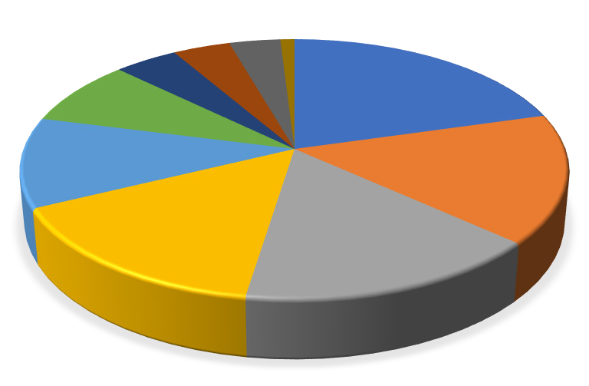

www.discover.arkansas.gov 9

Metropolitan Statistical Areas
Hot Springs MSA

The Hot Springs MSA = Garland County.

Civilian Labor Force Estimates (Not Seasonally Adjusted)

 | Nov 19 | Oct 19 | Nov 18 | OTM | OT Y
Civilian Labor Force | 40,662 | 40,985 | 40,099 | -323 | 563
Employment | 39,276 | 39,565 | 38,636 | -289 | 640
Unemployment | 1,386 | 1,420 | 1,463 | -34 | -77
Unemployment Rate | 3.4 | 3.5 | 3.6 | -0.1 | -0.2

Nonfarm Payroll Jobs (Not Seasonally Adjusted)
(In Thousands)

NAICS
Total Nonfarm Goods Producing Service Providing Government

Nov 19 | Oct 19 | Nov 18 | OTM | OT Y
39.2 | 39.3 | 38.7 | -0.1 | 0.5
4.4 | 4.4 | 4.4 | 0.0 | 0.0
34.8 | 34.9 | 34.3 | -0.1 | 0.5
4.6 | 4.5 | 4.6 | 0.1 | 0.0

40,000
Nonfarm Payroll Jobs
November: 1999 - 2019

39,000

38,000

37,000

36,000

35,000

34,000

33,000

32,000

'99 '00 '01 '02 '03 '04 '05 '06 '07 '08 '09 '10 '11 '12 '13 '14 '15 '16 '17 '18 '19

Metropolitan Statistical Areas
Jonesboro MSA

The Jonesboro MSA = Craighead & Poinsett counties.

Civilian Labor Force Estimates (Not Seasonally Adjusted)

 | Nov 19 | Oct 19 | Nov 18 | OTM | OT Y
Civilian Labor Force | 66,130 | 66,146 | 64,643 | -16 | 1,487
Employment | 64,461 | 64,452 | 62,894 | 9 | 1,567
Unemployment | 1,669 | 1,694 | 1,749 | -25 | -80
Unemployment Rate | 2.5 | 2.6 | 2.7 | -0.1 | -0.2

Nonfarm Payroll Jobs (Not Seasonally Adjusted)
(In Thousands)

NAICS
Total Nonfarm Goods Producing Service Providing Government

Nov 19 | Oct 19 | Nov 18 | OTM | OT Y
61.0 | 60.6 | 59.4 | 0.4 | 1.6
10.2 | 10.2 | 10.0 | 0.0 | 0.2
50.8 | 50.4 | 49.4 | 0.4 | 1.4
9.3 | 9.2 | 9.1 | 0.1 | 0.2

65,000
Number of Employed
January 2017 - November 2019

64,000

63,000

62,000

61,000

60,000

59,000

58,000

57,000

J F M A M J J A S O N D
2017 2018 2019

Metropolitan Statistical Areas
Pine Bluff MSA

The Pine Bluff MSA = Cleveland, Jefferson, & Lincoln counties.

Civilian Labor Force Estimates (Not Seasonally Adjusted)

 | Nov 19 | Oct 19 | Nov 18 | OTM | OT Y
Civilian Labor Force | 34,907 | 35,246 | 35,338 | -339 | -431
Employment | 33,211 | 33,601 | 33,735 | -390 | -524
Unemployment | 1,696 | 1,645 | 1,603 | 51 | 93
Unemployment Rate | 4.9 | 4.7 | 4.5 | 0.2 | 0.4

Nonfarm Payroll Jobs (Not Seasonally Adjusted)
(In Thousands)

NAICS
Total Nonfarm Goods Producing Service Providing Government

Nov 19 | Oct 19 | Nov 18 | OTM | OT Y
33.0 | 33.1 | 33.6 | -0.1 | -0.6
5.9 | 5.9 | 6.0 | 0.0 | -0.1
27.1 | 27.2 | 27.6 | -0.1 | -0.5
9.2 | 9.1 | 9.3 | 0.1 | -0.1

4,500
Number of Unemployed
November: 2009 - 2019

4,000

3,500

3,000

2,500

2,000

1,500

1,000

500

0
2009 2010 2011 2012 2013 2014 2015 2016 2017 2018 2019

Metropolitan Statistical Areas
Out-of-State MSA

Civilian Labor Force Estimates (Not Seasonally Adjusted)

Memphis, TN-MS-AR MSA

The Memphis, TN-MS-AR MSA = Fayette, Shelby, & Tipton counties in Tennessee; Benton, Desoto, Marshall, Tate, & Tunica counties in Mississippi; & Crittenden County in Arkansas.

 | Nov 19 | Oct 19 | Nov 18 | OTM | OT Y
Civilian Labor Force | 649,688 | 646,723 | 639,381 | 2,965 | 10,307
Employment | 624,442 | 621,998 | 616,430 | 2,444 | 8,012
Unemployment | 25,246 | 24,725 | 22,951 | 521 | 2,295
Unemployment Rate | 3.9 | 3.8 | 3.6 | 0.1 | 0.3

Texarkana MSA
The Texarkana MSA= Bowie County in Texas & Little River & Miller counties in Arkansas.

 | Nov 19 | Oct 19 | Nov 18 | OTM | OT Y
Civilian Labor Force | 65,217 | 64,953 | 65,391 | 264 | -174
Employment | 62,649 | 62,369 | 62,326 | 280 | 323
Unemployment | 2,568 | 2,584 | 3,065 | -16 | -497
Unemployment Rate | 3.9 | 4.0 | 4.7 | -0.1 | -0.8

Memphis MSA - Number of Unemployed
November: 2009 - 2019
70,000
Texarkana MSA - Unemployment Rates
November 2017 - November 2019
7.0

60,000
6.5

6.0

50,000
5.5

40,000
5.0

4.5

30,000

4.0

20,000
3.5 3.0

10,000
2.5

2.0

-
'09 '10 '11 '12 '13 '14 '15 '16 '17 '18 '19
Nov '17
May '18
Nov '18
May '19
Nov '19

Micropolitan Statistical Areas and Cities
Civilian Labor Force Estimates
Micropolitan Labor Force Estimates
Not Seasonally Adjusted
Micro Area
November 2019
CLF Emp Unemp Rate
October 2019
CLF Emp Unemp Rate
November 2018
CLF Emp Unemp Rate

Arkadelphia Micro | 9,786 | 9,447 | 339 | 3.5 | 9,787 | 9,446 | 341 | 3.5 | 9,923 | 9,595 | 328 | 3.3
Batesville Micro | 16,480 | 15,853 | 627 | 3.8 | 16,471 | 15,861 | 610 | 3.7 | 16,250 | 15,623 | 627 | 3.9
Blytheville Micro | 17,529 | 16,787 | 742 | 4.2 | 17,663 | 16,942 | 721 | 4.1 | 17,627 | 16,839 | 788 | 4.5
Camden Micro | 12,347 | 11,797 | 550 | 4.5 | 12,373 | 11,840 | 533 | 4.3 | 12,150 | 11,670 | 480 | 4.0
El Dorado Micro | 15,767 | 14,963 | 804 | 5.1 | 15,780 | 15,018 | 762 | 4.8 | 15,794 | 15,081 | 713 | 4.5
Forrest City Micro | 8,108 | 7,747 | 361 | 4.5 | 8,169 | 7,805 | 364 | 4.5 | 8,251 | 7,875 | 376 | 4.6
Harrison Micro | 19,397 | 18,826 | 571 | 2.9 | 19,458 | 18,881 | 577 | 3.0 | 18,984 | 18,431 | 553 | 2.9
Helena-West Helena Micro | 6,392 | 6,026 | 366 | 5.7 | 6,412 | 6,060 | 352 | 5.5 | 6,578 | 6,240 | 338 | 5.1
Hope Micro | 13,500 | 13,027 | 473 | 3.5 | 13,576 | 13,096 | 480 | 3.5 | 13,628 | 13,160 | 468 | 3.4
Magnolia Micro | 9,166 | 8,807 | 359 | 3.9 | 9,190 | 8,820 | 370 | 4.0 | 8,946 | 8,591 | 355 | 4.0
Malvern Micro | 13,956 | 13,502 | 454 | 3.3 | 14,007 | 13,532 | 475 | 3.4 | 13,908 | 13,461 | 447 | 3.2
Mountain Home Micro | 16,359 | 15,781 | 578 | 3.5 | 16,355 | 15,796 | 559 | 3.4 | 16,539 | 15,922 | 617 | 3.7
Paragould Micro | 19,944 | 19,307 | 637 | 3.2 | 19,988 | 19,366 | 622 | 3.1 | 19,603 | 19,010 | 593 | 3.0
Russellville Micro | 37,102 | 35,767 | 1,335 | 3.6 | 37,249 | 35,961 | 1,288 | 3.5 | 37,598 | 36,217 | 1,381 | 3.7
Searcy Micro | 33,938 | 32,543 | 1,395 | 4.1 | 33,863 | 32,573 | 1,290 | 3.8 | 33,743 | 32,465 | 1,278 | 3.8

Arkadelphia Micro = Clark County
Batesville Micro = Independence County Blytheville Micro = Mississippi County
Camden Micro = Calhoun & Ouachita counties El Dorado Micro = Union County
Forrest City Micro = St. Francis County
Harrison Micro = Boone & Newton counties Helena-West Helena Micro = Phillips County Hope Micro = Hempstead & Nevada counties Magnolia Micro = Columbia County

City Labor Force Statistics
Malvern Micro = Hot Spring County
Mountain Home Micro = Baxter County Paragould Micro = Greene County Russellville Micro = Pope & Yell counties Searcy Micro = White County

CLF
November 2019
Emp Unemp Rate
Not Seasonally Adjusted
October 2019
November 2018
City
CLF
Emp Unemp
Rate
CLF
Emp Unemp
Rate
www.discover.arkansas.gov
14

Bella Vista | 12,680 | 12,315 | 365 | 2.9 | 12,687 | 12,330 | 357 | 2.8 | 12,274 | 11,838 | 436 | 3.6
Benton | 17,404 | 16,955 | 449 | 2.6 | 17,425 | 16,954 | 471 | 2.7 | 17,150 | 16,664 | 486 | 2.8
Bentonville | 27,171 | 26,629 | 542 | 2.0 | 27,211 | 26,661 | 550 | 2.0 | 26,181 | 25,598 | 583 | 2.2
Blytheville | 5,984 | 5,677 | 307 | 5.1 | 6,011 | 5,730 | 281 | 4.7 | 5,982 | 5,695 | 287 | 4.8
Cabot | 12,137 | 11,772 | 365 | 3.0 | 12,170 | 11,800 | 370 | 3.0 | 11,969 | 11,641 | 328 | 2.7
Conway | 33,931 | 33,043 | 888 | 2.6 | 33,948 | 33,055 | 893 | 2.6 | 33,443 | 32,525 | 918 | 2.7
El Dorado | 6,834 | 6,464 | 370 | 5.4 | 6,862 | 6,488 | 374 | 5.5 | 6,853 | 6,515 | 338 | 4.9
Fayetteville | 49,317 | 48,212 | 1,105 | 2.2 | 49,358 | 48,265 | 1,093 | 2.2 | 47,481 | 46,353 | 1,128 | 2.4
Fort Smith | 39,506 | 38,310 | 1,196 | 3.0 | 39,402 | 38,162 | 1,240 | 3.1 | 39,280 | 38,038 | 1,242 | 3.2
Hot Springs | 14,492 | 13,936 | 556 | 3.8 | 14,635 | 14,039 | 596 | 4.1 | 14,309 | 13,709 | 600 | 4.2
Jacksonville | 11,956 | 11,438 | 518 | 4.3 | 11,936 | 11,437 | 499 | 4.2 | 11,670 | 11,240 | 430 | 3.7
Jonesboro | 39,119 | 38,169 | 950 | 2.4 | 39,128 | 38,136 | 992 | 2.5 | 38,182 | 37,170 | 1,012 | 2.7
Little Rock | 98,914 | 95,842 | 3,072 | 3.1 | 98,890 | 95,832 | 3,058 | 3.1 | 97,130 | 94,180 | 2,950 | 3.0
North Little Rock | 30,253 | 29,200 | 1,053 | 3.5 | 30,222 | 29,197 | 1,025 | 3.4 | 29,676 | 28,694 | 982 | 3.3
Paragould | 12,512 | 12,092 | 420 | 3.4 | 12,538 | 12,129 | 409 | 3.3 | 12,310 | 11,906 | 404 | 3.3
Pine Bluff | 16,570 | 15,562 | 1,008 | 6.1 | 16,719 | 15,730 | 989 | 5.9 | 16,680 | 15,766 | 914 | 5.5
Rogers | 36,683 | 35,917 | 766 | 2.1 | 36,766 | 35,960 | 806 | 2.2 | 35,380 | 34,525 | 855 | 2.4
Russellville | 13,324 | 12,890 | 434 | 3.3 | 13,400 | 12,946 | 454 | 3.4 | 13,459 | 13,018 | 441 | 3.3
Searcy | 10,285 | 9,947 | 338 | 3.3 | 10,293 | 9,956 | 337 | 3.3 | 10,295 | 9,923 | 372 | 3.6
Sherwood | 16,181 | 15,735 | 446 | 2.8 | 16,180 | 15,733 | 447 | 2.8 | 15,897 | 15,462 | 435 | 2.7
Springdale | 40,555 | 39,699 | 856 | 2.1 | 40,658 | 39,743 | 915 | 2.3 | 39,058 | 38,167 | 891 | 2.3
Texarkana, AR | 13,645 | 13,109 | 536 | 3.9 | 13,581 | 13,065 | 516 | 3.8 | 13,640 | 13,005 | 635 | 4.7
Van Buren | 10,384 | 10,090 | 294 | 2.8 | 10,365 | 10,063 | 302 | 2.9 | 10,370 | 10,044 | 326 | 3.1
West Memphis | 10,755 | 10,301 | 454 | 4.2 | 10,720 | 10,241 | 479 | 4.5 | 10,657 | 10,235 | 422 | 4.0

County Labor Force Statistics
Civilian Labor Force Estimates
Not Seasonally Adjusted
County
November 2019
CLF Emp Unemp Rate
October 2019
CLF Emp Unemp Rate
November 2018
CLF Emp Unemp Rate

Arkansas | 9,536 | 9,266 | 270 | 2.8 | 9,589 | 9,338 | 251 | 2.6 | 9,086 | 8,811 | 275 | 3.0
Ashley | 7,773 | 7,381 | 392 | 5.0 | 7,814 | 7,473 | 341 | 4.4 | 7,693 | 7,328 | 365 | 4.7
Baxter | 16,359 | 15,781 | 578 | 3.5 | 16,355 | 15,796 | 559 | 3.4 | 16,539 | 15,922 | 617 | 3.7
Benton | 139,926 | 136,740 | 3,186 | 2.3 | 140,153 | 136,904 | 3,249 | 2.3 | 134,848 | 131,444 | 3,404 | 2.5
Boone | 16,049 | 15,584 | 465 | 2.9 | 16,096 | 15,621 | 475 | 3.0 | 15,693 | 15,229 | 464 | 3.0
Bradley | 4,501 | 4,349 | 152 | 3.4 | 4,557 | 4,398 | 159 | 3.5 | 4,514 | 4,347 | 167 | 3.7
Calhoun | 2,435 | 2,339 | 96 | 3.9 | 2,441 | 2,356 | 85 | 3.5 | 2,417 | 2,338 | 79 | 3.3
Carroll | 12,508 | 12,175 | 333 | 2.7 | 12,841 | 12,505 | 336 | 2.6 | 12,536 | 12,213 | 323 | 2.6
Chicot | 3,308 | 3,110 | 198 | 6.0 | 3,339 | 3,150 | 189 | 5.7 | 3,291 | 3,100 | 191 | 5.8
Clark | 9,786 | 9,447 | 339 | 3.5 | 9,787 | 9,446 | 341 | 3.5 | 9,923 | 9,595 | 328 | 3.3
Clay | 5,633 | 5,376 | 257 | 4.6 | 5,652 | 5,431 | 221 | 3.9 | 5,854 | 5,638 | 216 | 3.7
Cleburne | 9,204 | 8,803 | 401 | 4.4 | 9,257 | 8,863 | 394 | 4.3 | 9,132 | 8,782 | 350 | 3.8
Cleveland | 3,245 | 3,124 | 121 | 3.7 | 3,290 | 3,171 | 119 | 3.6 | 3,312 | 3,201 | 111 | 3.4
Columbia | 9,166 | 8,807 | 359 | 3.9 | 9,190 | 8,820 | 370 | 4.0 | 8,946 | 8,591 | 355 | 4.0
Conway | 8,246 | 7,933 | 313 | 3.8 | 8,274 | 7,954 | 320 | 3.9 | 8,182 | 7,867 | 315 | 3.8
Craighead | 55,642 | 54,293 | 1,349 | 2.4 | 55,620 | 54,246 | 1,374 | 2.5 | 54,304 | 52,872 | 1,432 | 2.6
Crawford | 26,759 | 25,984 | 775 | 2.9 | 26,731 | 25,914 | 817 | 3.1 | 26,686 | 25,865 | 821 | 3.1
Crittenden | 21,782 | 21,000 | 782 | 3.6 | 21,674 | 20,877 | 797 | 3.7 | 21,638 | 20,865 | 773 | 3.6
Cross | 7,349 | 7,065 | 284 | 3.9 | 7,416 | 7,131 | 285 | 3.8 | 7,411 | 7,120 | 291 | 3.9
Dallas | 2,846 | 2,721 | 125 | 4.4 | 2,848 | 2,730 | 118 | 4.1 | 2,870 | 2,769 | 101 | 3.5
Desha | 5,552 | 5,329 | 223 | 4.0 | 5,594 | 5,382 | 212 | 3.8 | 5,525 | 5,318 | 207 | 3.7
Drew | 7,895 | 7,513 | 382 | 4.8 | 7,898 | 7,544 | 354 | 4.5 | 7,982 | 7,641 | 341 | 4.3
Faulkner | 62,240 | 60,535 | 1,705 | 2.7 | 62,280 | 60,558 | 1,722 | 2.8 | 61,320 | 59,586 | 1,734 | 2.8
Franklin | 7,401 | 7,173 | 228 | 3.1 | 7,473 | 7,238 | 235 | 3.1 | 7,402 | 7,179 | 223 | 3.0
Fulton | 4,870 | 4,712 | 158 | 3.2 | 4,897 | 4,735 | 162 | 3.3 | 4,751 | 4,582 | 169 | 3.6
Garland | 40,662 | 39,276 | 1,386 | 3.4 | 40,985 | 39,565 | 1,420 | 3.5 | 40,099 | 38,636 | 1,463 | 3.6
Grant | 8,466 | 8,210 | 256 | 3.0 | 8,483 | 8,231 | 252 | 3.0 | 8,333 | 8,114 | 219 | 2.6
Greene | 19,944 | 19,307 | 637 | 3.2 | 19,988 | 19,366 | 622 | 3.1 | 19,603 | 19,010 | 593 | 3.0
Hempstead | 9,886 | 9,542 | 344 | 3.5 | 9,945 | 9,599 | 346 | 3.5 | 10,012 | 9,654 | 358 | 3.6
Hot Spring | 13,956 | 13,502 | 454 | 3.3 | 14,007 | 13,532 | 475 | 3.4 | 13,908 | 13,461 | 447 | 3.2
Howard | 5,612 | 5,443 | 169 | 3.0 | 5,642 | 5,482 | 160 | 2.8 | 5,854 | 5,663 | 191 | 3.3
Independence | 16,480 | 15,853 | 627 | 3.8 | 16,471 | 15,861 | 610 | 3.7 | 16,250 | 15,623 | 627 | 3.9
Izard | 4,926 | 4,671 | 255 | 5.2 | 4,911 | 4,691 | 220 | 4.5 | 4,877 | 4,625 | 252 | 5.2
Jackson | 5,883 | 5,520 | 363 | 6.2 | 5,930 | 5,573 | 357 | 6.0 | 5,832 | 5,513 | 319 | 5.5
Jefferson | 27,707 | 26,284 | 1,423 | 5.1 | 27,942 | 26,567 | 1,375 | 4.9 | 27,970 | 26,628 | 1,342 | 4.8
Johnson | 10,292 | 9,915 | 377 | 3.7 | 10,251 | 9,867 | 384 | 3.7 | 10,522 | 10,141 | 381 | 3.6
Lafayette | 2,488 | 2,384 | 104 | 4.2 | 2,497 | 2,388 | 109 | 4.4 | 2,529 | 2,418 | 111 | 4.4
Lawrence | 6,952 | 6,690 | 262 | 3.8 | 6,975 | 6,731 | 244 | 3.5 | 6,989 | 6,750 | 239 | 3.4
Lee | 2,855 | 2,729 | 126 | 4.4 | 2,888 | 2,770 | 118 | 4.1 | 2,931 | 2,812 | 119 | 4.1
Lincoln | 3,955 | 3,803 | 152 | 3.8 | 4,014 | 3,863 | 151 | 3.8 | 4,056 | 3,906 | 150 | 3.7
Little River | 5,514 | 5,291 | 223 | 4.0 | 5,495 | 5,274 | 221 | 4.0 | 5,508 | 5,243 | 265 | 4.8
Logan | 8,530 | 8,180 | 350 | 4.1 | 8,585 | 8,221 | 364 | 4.2 | 8,729 | 8,422 | 307 | 3.5
Lonoke | 34,346 | 33,320 | 1,026 | 3.0 | 34,410 | 33,397 | 1,013 | 2.9 | 33,882 | 32,947 | 935 | 2.8
Madison | 7,646 | 7,478 | 168 | 2.2 | 7,716 | 7,533 | 183 | 2.4 | 7,516 | 7,337 | 179 | 2.4
Marion | 6,560 | 6,331 | 229 | 3.5 | 6,611 | 6,367 | 244 | 3.7 | 6,447 | 6,190 | 257 | 4.0
Miller | 19,791 | 19,066 | 725 | 3.7 | 19,711 | 19,002 | 709 | 3.6 | 19,747 | 18,914 | 833 | 4.2
(continued on Page 16)

County Labor Force Statistics
Civilian Labor Force Estimates
(continued from Page 15)
Not Seasonally Adjusted
County
November 2019
CLF Emp Unemp Rate
October 2019
CLF Emp Unemp Rate
November 2018
CLF Emp Unemp Rate

Mississippi | 17,529 | 16,787 | 742 | 4.2 | 17,663 | 16,942 | 721 | 4.1 | 17,627 | 16,839 | 788 | 4.5
Monroe | 2,724 | 2,609 | 115 | 4.2 | 2,769 | 2,658 | 111 | 4.0 | 2,697 | 2,593 | 104 | 3.9
Montgomery | 2,925 | 2,792 | 133 | 4.5 | 2,968 | 2,842 | 126 | 4.2 | 3,032 | 2,905 | 127 | 4.2
Nevada | 3,614 | 3,485 | 129 | 3.6 | 3,631 | 3,497 | 134 | 3.7 | 3,616 | 3,506 | 110 | 3.0
Newton | 3,348 | 3,242 | 106 | 3.2 | 3,362 | 3,260 | 102 | 3.0 | 3,291 | 3,202 | 89 | 2.7
Ouachita | 9,912 | 9,458 | 454 | 4.6 | 9,932 | 9,484 | 448 | 4.5 | 9,733 | 9,332 | 401 | 4.1
Perry | 4,270 | 4,129 | 141 | 3.3 | 4,280 | 4,138 | 142 | 3.3 | 4,251 | 4,091 | 160 | 3.8
Phillips | 6,392 | 6,026 | 366 | 5.7 | 6,412 | 6,060 | 352 | 5.5 | 6,578 | 6,240 | 338 | 5.1
Pike | 4,257 | 4,105 | 152 | 3.6 | 4,293 | 4,141 | 152 | 3.5 | 4,258 | 4,108 | 150 | 3.5
Poinsett | 10,488 | 10,168 | 320 | 3.1 | 10,526 | 10,206 | 320 | 3.0 | 10,339 | 10,022 | 317 | 3.1
Polk | 8,022 | 7,678 | 344 | 4.3 | 8,018 | 7,686 | 332 | 4.1 | 7,990 | 7,719 | 271 | 3.4
Pope | 28,726 | 27,659 | 1,067 | 3.7 | 28,789 | 27,778 | 1,011 | 3.5 | 29,017 | 27,933 | 1,084 | 3.7
Prairie | 3,571 | 3,431 | 140 | 3.9 | 3,600 | 3,467 | 133 | 3.7 | 3,595 | 3,465 | 130 | 3.6
Pulaski | 192,160 | 186,109 | 6,051 | 3.1 | 192,132 | 186,090 | 6,042 | 3.1 | 188,635 | 182,882 | 5,753 | 3.0
Randolph | 7,359 | 7,113 | 246 | 3.3 | 7,387 | 7,151 | 236 | 3.2 | 7,238 | 7,008 | 230 | 3.2
St. Francis | 8,108 | 7,747 | 361 | 4.5 | 8,169 | 7,805 | 364 | 4.5 | 8,251 | 7,875 | 376 | 4.6
Saline | 58,502 | 56,979 | 1,523 | 2.6 | 58,537 | 56,973 | 1,564 | 2.7 | 57,547 | 56,001 | 1,546 | 2.7
Scott | 4,307 | 4,168 | 139 | 3.2 | 4,339 | 4,200 | 139 | 3.2 | 4,419 | 4,283 | 136 | 3.1
Searcy | 2,869 | 2,747 | 122 | 4.3 | 2,898 | 2,773 | 125 | 4.3 | 2,907 | 2,792 | 115 | 4.0
Sebastian | 56,937 | 55,240 | 1,697 | 3.0 | 56,766 | 55,027 | 1,739 | 3.1 | 56,582 | 54,848 | 1,734 | 3.1
Sevier | 5,424 | 5,188 | 236 | 4.4 | 5,464 | 5,217 | 247 | 4.5 | 5,571 | 5,342 | 229 | 4.1
Sharp | 5,675 | 5,410 | 265 | 4.7 | 5,705 | 5,445 | 260 | 4.6 | 5,761 | 5,514 | 247 | 4.3
Stone | 4,704 | 4,505 | 199 | 4.2 | 4,753 | 4,571 | 182 | 3.8 | 4,856 | 4,638 | 218 | 4.5
Union | 15,767 | 14,963 | 804 | 5.1 | 15,780 | 15,018 | 762 | 4.8 | 15,794 | 15,081 | 713 | 4.5
Van Buren | 5,683 | 5,424 | 259 | 4.6 | 5,709 | 5,457 | 252 | 4.4 | 5,857 | 5,586 | 271 | 4.6
Washington | 127,684 | 124,988 | 2,696 | 2.1 | 127,918 | 125,126 | 2,792 | 2.2 | 122,997 | 120,169 | 2,828 | 2.3
White | 33,938 | 32,543 | 1,395 | 4.1 | 33,863 | 32,573 | 1,290 | 3.8 | 33,743 | 32,465 | 1,278 | 3.8
Woodruff | 2,786 | 2,651 | 135 | 4.8 | 2,831 | 2,702 | 129 | 4.6 | 2,853 | 2,727 | 126 | 4.4
Yell | 8,376 | 8,108 | 268 | 3.2 | 8,460 | 8,183 | 277 | 3.3 | 8,581 | 8,284 | 297 | 3.5

County Labor Force Summary
Between October and November, unemployment rates increased in 41 of Arkansas’ 75 counties. Rates declined in twenty-one counties and remained stable in thirteen. Jobless rates ranged from a low of 2.1 percent in Washington County to a high of 6.2 percent in Jackson County.

In November, forty-eight counties posted unemployment rates at or below four percent. That is down slightly from 52 counties at or below four percent in October. For the fourth month in a row, no county reported a jobless rate above seven percent.
Compared to November 2018, unemployment rates are up in 41 Arkansas counties. Twenty-
seven counties posted rate declines, while seven counties were the same over-the-year.

County Unemployment Rates
www.discover.arkansas.gov
17

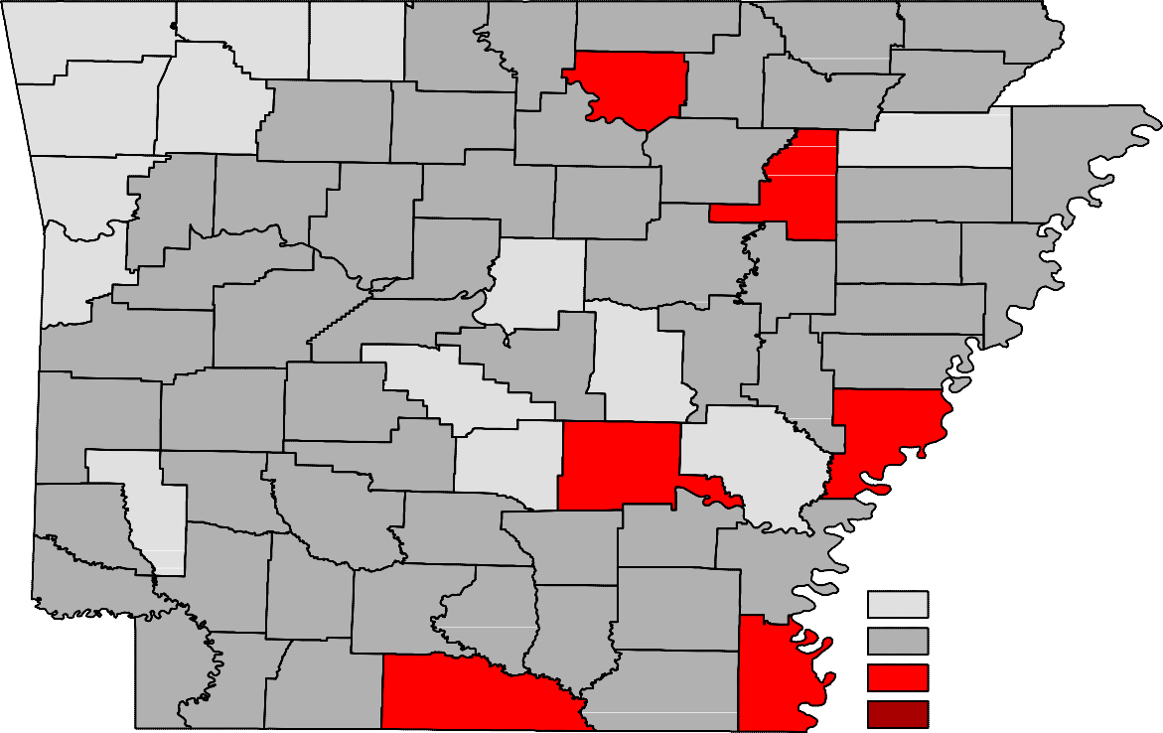
Benton
Carroll
Fulton
Clay
Boone
Randolph
Marion
Baxter
Sharp
Izard
Greene
Madison
Washington
Lawrence
Newton
Searcy
Stone
Independence
Craighead Mississippi
Crawford
Johnson
Van Buren
Jackson
Franklin
Cleburne
Poinsett
Pope
Conway
Cross
Sebastian
Logan
White
Crittenden
Faulkner
Woodruff
Yell
St. Francis
Perry
Scott
Prairie
Pulaski Lonoke
Lee
Saline
Monroe
Montgomery
Garland
Polk
Phillips
Howard
Hot Spring Grant
Jefferson
Arkansas
Pike
Sevier
Clark
Dallas
Lincoln
Cleveland
Desha
Little River Hempstead
Nevada
Ouachita
Calhoun
Drew
Bradley
Miller
Lafayette Columbia
Chicot
Union
Ashley
Unemployment Rates
< or = 3.0% 3.1% - 5.0%
5.1% - 7.0%
> 7.0% [NONE]

Ranked by Unemployment Rates
November 2019 (Not Seasonally Adjusted)

Rank  1 | County  Washington | Rate  2.1 | Rank  26 | County  Bradley | Rate  3.4 | Rank  51 | County  Lafayette | Rate  4.2
2 | Madison | 2.2 | 26 | Garland | 3.4 | 51 | Mississippi | 4.2
3 | Benton | 2.3 | 28 | Baxter | 3.5 | 51 | Monroe | 4.2
4 | Craighead | 2.4 | 28 | Clark | 3.5 | 51 | Stone | 4.2
5 | Saline | 2.6 | 28 | Hempstead | 3.5 | 55 | Polk | 4.3
6 | Carroll | 2.7 | 28 | Marion | 3.5 | 55 | Searcy | 4.3
6 | Faulkner | 2.7 | 32 | Crittenden | 3.6 | 57 | Cleburne | 4.4
8 | Arkansas | 2.8 | 32 | Nevada | 3.6 | 57 | Dallas | 4.4
9 | Boone | 2.9 | 32 | Pike | 3.6 | 57 | Lee | 4.4
9 | Crawford | 2.9 | 35 | Cleveland | 3.7 | 57 | Sevier | 4.4
11 | Grant | 3.0 | 35 | Johnson | 3.7 | 61 | Montgomery | 4.5
11 | Howard | 3.0 | 35 | Miller | 3.7 | 61 | St. Francis | 4.5
11 | Lonoke | 3.0 | 35 | Pope | 3.7 | 63 | Clay | 4.6
11 | Sebastian | 3.0 | 39 | Conway | 3.8 | 63 | Ouachita | 4.6
15 | Franklin | 3.1 | 39 | Independence | 3.8 | 63 | Van Buren | 4.6
15 | Poinsett | 3.1 | 39 | Lawrence | 3.8 | 66 | Sharp | 4.7
15 | Pulaski | 3.1 | 39 | Lincoln | 3.8 | 67 | Drew | 4.8
18 | Fulton | 3.2 | 43 | Calhoun | 3.9 | 67 | Woodruff | 4.8
18 | Greene | 3.2 | 43 | Columbia | 3.9 | 69 | Ashley | 5.0
18 | Newton | 3.2 | 43 | Cross | 3.9 | 70 | Jefferson | 5.1
18 | Scott | 3.2 | 43 | Prairie | 3.9 | 70 | Union | 5.1
18 | Yell | 3.2 | 47 | Desha | 4.0 | 72 | Izard | 5.2
23 | Hot Spring | 3.3 | 47 | Little River | 4.0 | 73 | Phillips | 5.7
23 | Perry | 3.3 | 49 | Logan | 4.1 | 74 | Chicot | 6.0
23 | Randolph | 3.3 | 49 | White | 4.1 | 75 | Jackson | 6.2

Local Workforce Development Areas
Civilian Labor Force Estimates
Not Seasonally Adjusted

LWDA CLF |  | November 2019  Emp Unemp |  | Rate | CLF | October 2019  Emp Unemp |  | Rate | November 2018  CLF Emp Unemp Rate
Central (minus LR) | 254,629 | 247,141 | 7,488 | 2.9 | 254,838 | 247,311 | 7,527 | 3.0 | 250,546 | 243,294 | 7,252 | 2.9
City of Little Rock | 98,914 | 95,842 | 3,072 | 3.1 | 98,890 | 95,832 | 3,058 | 3.1 | 97,130 | 94,180 | 2,950 | 3.0
Eastern | 46,486 | 44,567 | 1,919 | 4.1 | 46,559 | 44,643 | 1,916 | 4.1 | 46,809 | 44,912 | 1,897 | 4.1
North Central | 94,149 | 90,092 | 4,057 | 4.3 | 94,327 | 90,471 | 3,856 | 4.1 | 93,912 | 90,055 | 3,857 | 4.1
Northeast | 123,547 | 119,734 | 3,813 | 3.1 | 123,811 | 120,073 | 3,738 | 3.0 | 121,954 | 118,139 | 3,815 | 3.1
Northwest | 332,949 | 325,066 | 7,883 | 2.4 | 333,950 | 325,885 | 8,065 | 2.4 | 322,774 | 314,498 | 8,276 | 2.6
Southeast | 81,938 | 78,369 | 3,569 | 4.4 | 82,520 | 79,117 | 3,403 | 4.1 | 81,762 | 78,394 | 3,368 | 4.1
Southwest | 92,455 | 88,687 | 3,768 | 4.1 | 92,576 | 88,867 | 3,709 | 4.0 | 92,597 | 88,851 | 3,746 | 4.0
West Central | 131,496 | 126,866 | 4,630 | 3.5 | 132,094 | 127,446 | 4,648 | 3.5 | 131,773 | 127,021 | 4,752 | 3.6
Western | 111,956 | 108,423 | 3,533 | 3.2 | 111,912 | 108,286 | 3,626 | 3.2 | 111,808 | 108,316 | 3,492 | 3.1

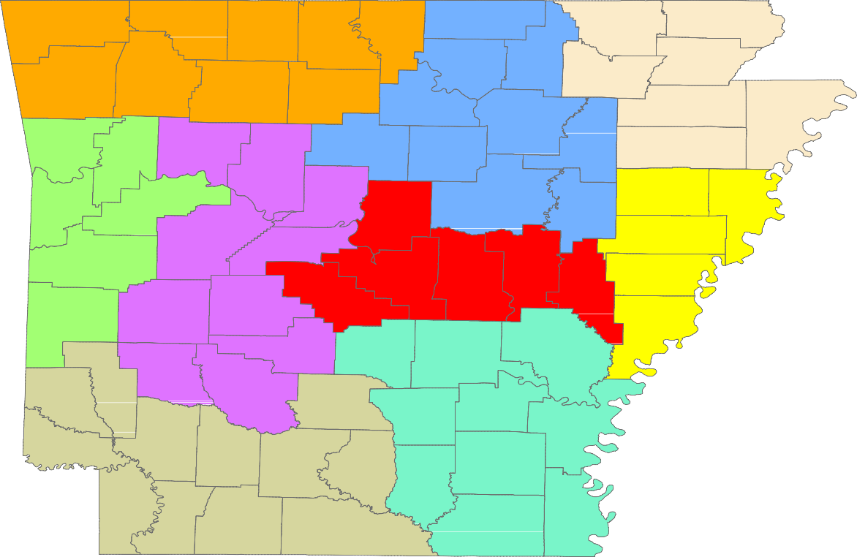
Benton
Carroll
Fulton
Clay
Boone
Randolph
Marion
Baxter
Sharp
Izard
Greene
Madison
Washington
Lawrence
Newton
Searcy
Stone
Craighead
Mississippi
Independence
Crawford
Johnson
Van Buren
Jackson
Franklin
Cleburne
Poinsett
Pope
Conway
Cross
Sebastian
Logan
White
Crittenden
Faulkner
Woodruff
Yell
St. Francis
Perry
Scott
Prairie
Pulaski Lonoke
Lee
Saline
Monroe
Montgomery
Garland
Polk
Phillips
Hot Spring
Grant
Jefferson
Arkansas
Pike
Howard
Clark
Sevier
Dallas
Lincoln
Cleveland
Desha
Little River Hempstead
Nevada
Ouachita
Calhoun
Drew
Bradley
Miller
Columbia
Chicot
Union
Ashley
Lafayette

Central (minus LR) Eastern
North Central
Northeast Northwest Southeast
Southwest West Central Western

www.discover.arkansas.gov
18

