

**FOR IMMEDIATE RELEASE**

Contact: Zoe Dell, [zoe.dell@arkansas.gov](mailto:zoe.dell@arkansas.gov)

Arkansas’ unemployment rate increases to 3.7% in March

**LITTLE ROCK, Ark. (April 18, 2025)** Today, the Arkansas Department of Commerce, in conjunction with the Bureau of Labor Statistics, announced Arkansas’ seasonally adjusted unemployment rate rose one-tenth of a percentage point, from 3.6% in February to 3.7% in March. The United States’ jobless rate also increased one- tenth of a percentage point over the month, up to 4.2% in March.

Arkansas Civilian Labor Force Summary:

* Arkansas’ civilian labor force increased by 260 in March, a result of 502 more unemployed job seekers and 242 fewer employed Arkansans. The unemployment rate increased by one-tenth of a percentage point, while the labor force participation rate remained stable over the month.
* Compared to March 2024, there are 15,686 more employed in the State. There are 4,739 more unemployed Arkansans actively seeking work, as the unemployment rate is up from 3.4%. Arkansas’ labor force participation rate is up four-tenths of a percentage point over the year.

Arkansas Nonfarm Payroll Job Summary:

* Nonfarm payroll jobs in Arkansas rose 5,200 in March to total 1,378,100. The greatest gains were posted in Leisure and Hospitality (+3,200), Manufacturing (+1,200), Construction (+1,100), and Private Education and Health Services (+1,100). The largest loss occurred in Professional and Business Services (-2,100), mostly due to declines in administrative and support services (-1,900).
* Compared to March 2024, there are 13,000 more jobs in the State. The largest annual growth was in Private Education and Health Services (+7,500), with health care and social assistance adding 7,100 jobs. Other notable gains were posted in Trade-Transportation-Utilities (+4,700) and in Manufacturing (+2,100).

# Arkansas Civilian Labor Force (Seasonally Adjusted)

|  |  |  |  |  |  |
| --- | --- | --- | --- | --- | --- |
|  | March 2025 | February  2025 | March 2024 | Change from February 2025 | Change from March 2024 |
| Civilian Labor Force | 1,421,038 | 1,420,778 | 1,400,613 | 260 | 20,425 |
| Employment | 1,368,961 | 1,369,203 | 1,353,275 | -242 | 15,686 |
| Unemployment | 52,077 | 51,575 | 47,338 | 502 | 4,739 |
| Unemployment Rate | 3.7% | 3.6% | 3.4% | 0.1% | 0.3% |
| Labor Force Participation Rate | 58.4% | 58.4% | 58.0% | 0.0% | 0.4% |

Source: U.S. Bureau of Labor Statistics, Current Population Survey. More information about the data is available at <https://www.bls.gov/cps/definitions.htm>

# Arkansas Nonfarm Payroll Jobs (Not Seasonally Adjusted, In Thousands)

|  |  |  |  |  |  |
| --- | --- | --- | --- | --- | --- |
| Industry Sector based on 2022 North American Industry Classification System (NAICS) | March 2025 | February  2025 | March 2024 | Change  from February  2025 | Change  from March 2024 |
| Total Nonfarm Payroll Jobs | 1378.1 | 1372.9 | 1365.1 | 5.2 | 13.0 |
| Goods Producing | 234.8 | 232.5 | 234.0 | 2.3 | 0.8 |
| Mining, Logging, & Construction | 70.2 | 69.1 | 71.5 | 1.1 | -1.3 |
| **Mining & Logging** | **5.1** | **5.1** | **5.3** | **0.0** | **-0.2** |
| **Construction** | **65.1** | **64.0** | **66.2** | **1.1** | **-1.1** |
| Specialty Trade Contractors | 41.0 | 40.3 | 41.3 | 0.7 | -0.3 |
| **Manufacturing** | **164.6** | **163.4** | **162.5** | **1.2** | **2.1** |
| Durable Goods | 78.9 | 78.0 | 77.6 | 0.9 | 1.3 |
| Nondurable Goods | 85.7 | 85.4 | 84.9 | 0.3 | 0.8 |
| Service Providing | 1143.3 | 1140.4 | 1131.1 | 2.9 | 12.2 |
| **Trade, Transportation, & Utilities** | **271.6** | **270.7** | **266.9** | **0.9** | **4.7** |
| Wholesale Trade | 53.7 | 53.9 | 53.0 | -0.2 | 0.7 |
| Retail Trade | 145.2 | 144.6 | 143.0 | 0.6 | 2.2 |
| Transportation, Warehousing, & Utilities | 72.7 | 72.2 | 70.9 | 0.5 | 1.8 |
| **Information** | **11.5** | **11.8** | **12.6** | **-0.3** | **-1.1** |
| **Financial Activities** | **69.8** | **70.2** | **69.3** | **-0.4** | **0.5** |
| Finance & Insurance | 54.9 | 55.2 | 54.0 | -0.3 | 0.9 |
| Real Estate, Rental, & Leasing | 14.9 | 15.0 | 15.3 | -0.1 | -0.4 |
| **Professional & Business Services** | **160.6** | **162.7** | **160.2** | **-2.1** | **0.4** |
| Professional, Scientific, & Technical | 54.4 | 54.7 | 51.6 | -0.3 | 2.8 |
| Management of Companies | 40.8 | 40.7 | 39.0 | 0.1 | 1.8 |
| Administrative & Support Services | 65.4 | 67.3 | 69.6 | -1.9 | -4.2 |
| **Private Education & Health Services** | **220.2** | **219.1** | **212.7** | **1.1** | **7.5** |
| Educational Services | 20.2 | 19.8 | 19.8 | 0.4 | 0.4 |
| Health Care & Social Assistance | 200.0 | 199.3 | 192.9 | 0.7 | 7.1 |
| Ambulatory Health Care | 69.3 | 69.4 | 66.8 | -0.1 | 2.5 |
| Social Assistance | 42.5 | 42.1 | 40.2 | 0.4 | 2.3 |
| **Leisure & Hospitality** | **128.1** | **124.9** | **128.1** | **3.2** | **0.0** |
| Arts, Entertainment, & Recreation | 13.4 | 13.0 | 13.4 | 0.4 | 0.0 |
| Accommodation & Food Services | 114.7 | 111.9 | 114.7 | 2.8 | 0.0 |
| Accommodation Services | 10.9 | 10.5 | 11.0 | 0.4 | -0.1 |
| Food Services | 103.8 | 101.4 | 103.7 | 2.4 | 0.1 |
| **Other Services** | **65.6** | **65.7** | **65.6** | **-0.1** | **0.0** |
| **Government** | **215.9** | **215.3** | **215.7** | **0.6** | **0.2** |
| Federal Government | 21.8 | 21.8 | 21.9 | 0.0 | -0.1 |
| State Government | 78.2 | 77.9 | 78.2 | 0.3 | 0.0 |
| State Government, Educational Services | 32.2 | 31.9 | 32.1 | 0.3 | 0.1 |
| State Government, Excluding Education | 46.0 | 46.0 | 46.1 | 0.0 | -0.1 |
| Local Government | 115.9 | 115.6 | 115.6 | 0.3 | 0.3 |
| Local Government, Educational Services | 70.9 | 70.9 | 70.3 | 0.0 | 0.6 |
| Local Government, Excluding Education | 45.0 | 44.7 | 45.3 | 0.3 | -0.3 |

Source**:** Monthly Survey of Employers, based on 1st Quarter 2024 benchmark. Notes: Current month’s data are preliminary; previous month’s data are revised.

# Seasonally Adjusted Unemployment Rates Arkansas vs. United States (3-Year Comparison)

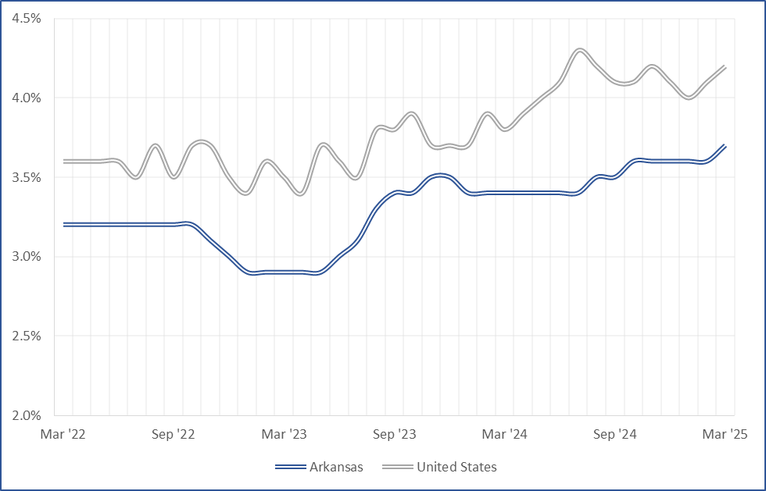

**Job Gains/Losses by Major Industry Sectors March 2024 to March 2025 (Not Seasonally Adjusted)**

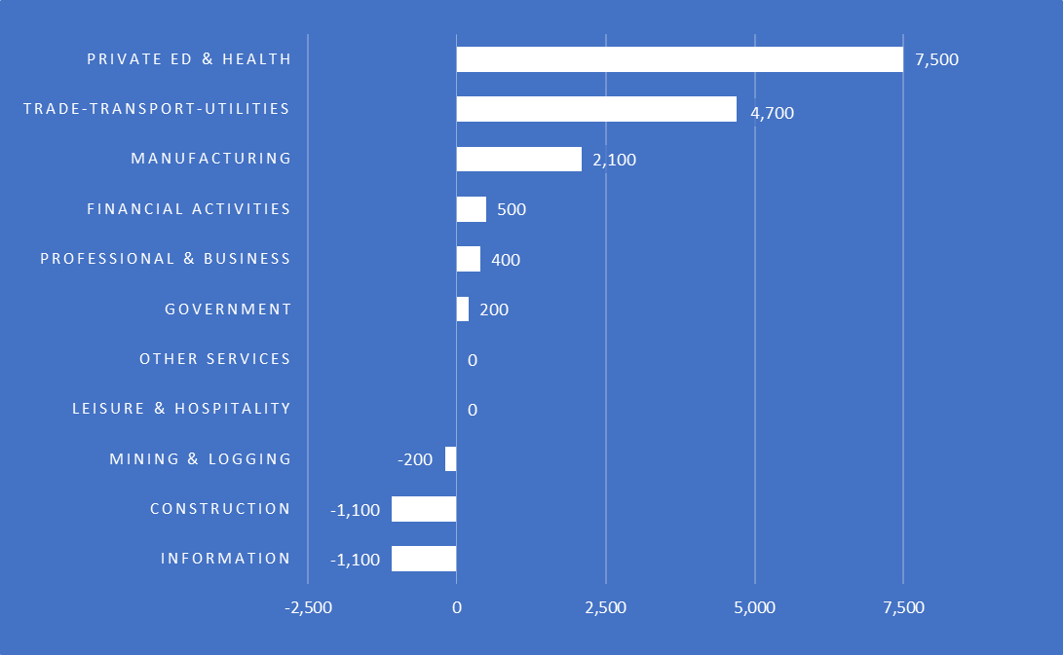

For more Labor Market Data, visit our website at [www.discover.arkansas.gov](http://www.discover.arkansas.gov/)

**About the Arkansas Department of Commerce**

The Arkansas Department of Commerce is the umbrella department for workforce and economic development drivers. Its divisions and regulatory boards include the Division of Aeronautics, Waterways Commission, Wine Producers Council, Workforce Services, State Bank Department, Insurance Department, Securities Department, Economic Development Commission, and Development Finance Authority.



**About Bureau of Labor Statistics (BLS)**

The Bureau of Labor Statistics measures labor market activity, working conditions, price changes, and productivity In the U.S. economy to support public and private decision making.

**About Local Area Unemployment Statistics (LAUS)**

The LAUS program produces monthly and annual employment, unemployment, and labor force data for Census regions and divisions, States, counties, metropolitan areas, and many cities, by place of residence.

**About Current Employment Statistics (CES)**

The CES program produces detailed industry estimates of employment, hours, and earnings of workers on nonfarm payrolls. CES State and Metro Area produces data for all 50 States, the District of Columbia, Puerto Rico, the Virgin Islands, and about 450 metropolitan areas and divisions.